**Equip9 Assessment**

**Name**: Yash Nathe  
**Email**: yashnathe2001@gmail.com  
**Mobile Number**: 7058088965  
**Date**: 31-12-2024

**Task Part 1:**

**Write a Terraform layout to provision AWS infrastructure and deploy the HTTP service created in Part 1.**

**Steps:**

**Step 1: Install Terraform**

1. **Download Terraform (https://developer.hashicorp.com/terraform/install)**
2. **Install it on your system and verify the installation:**



**Step 2: Write the Terraform Configuration**

**Create a file named main.tf with the following content:**

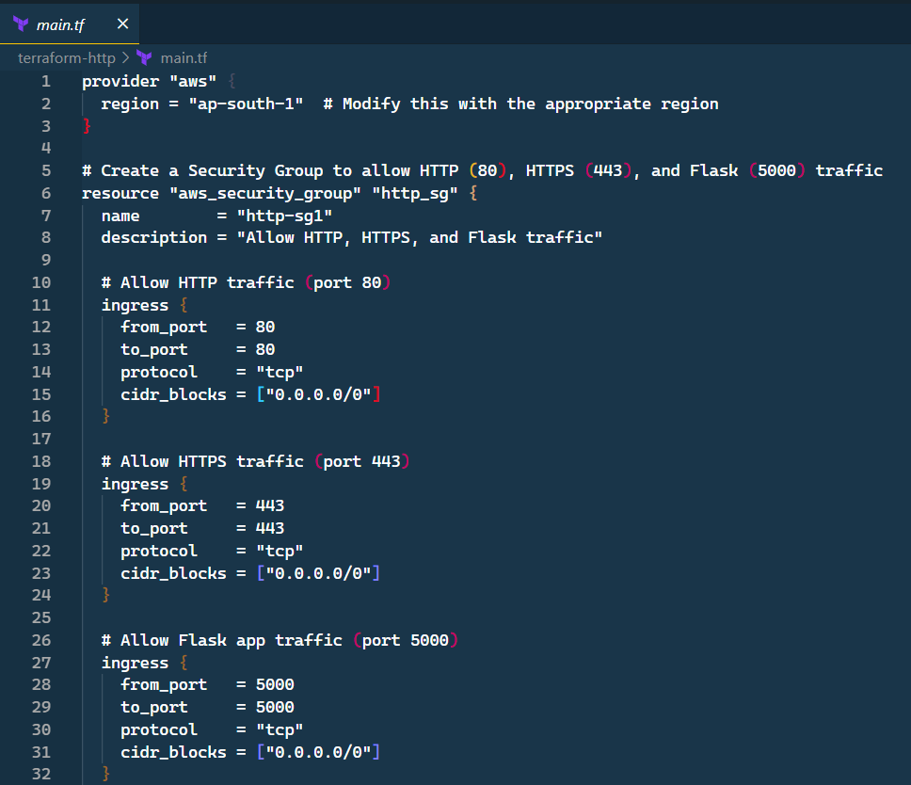

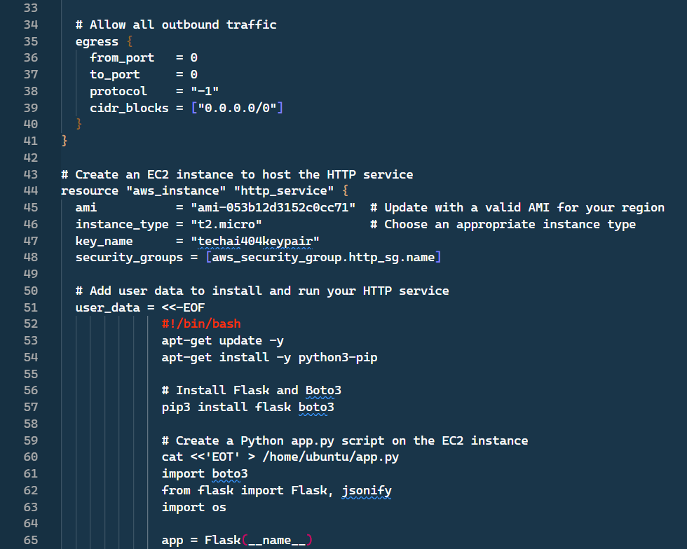

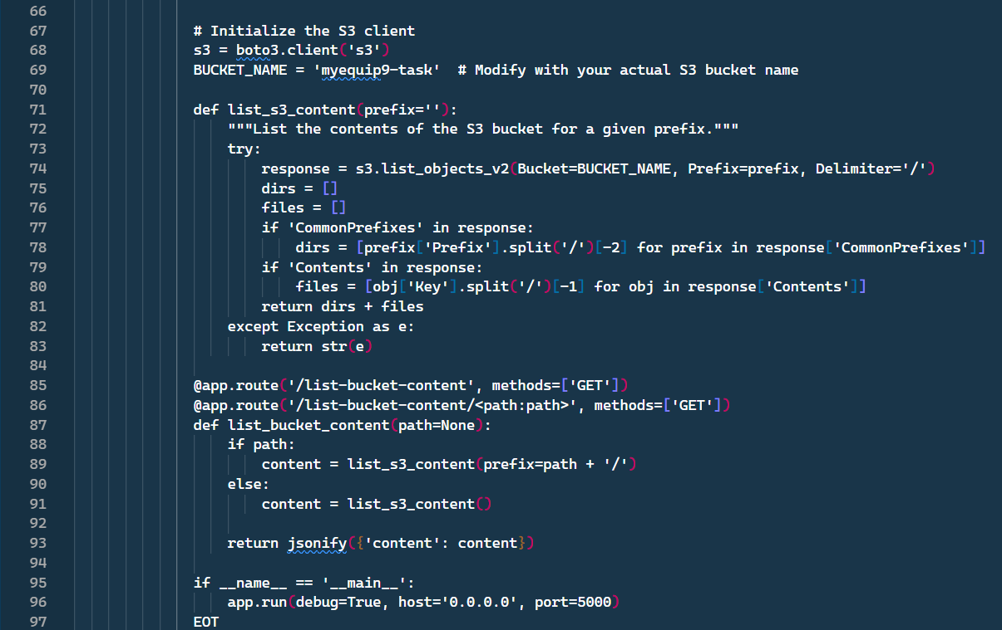

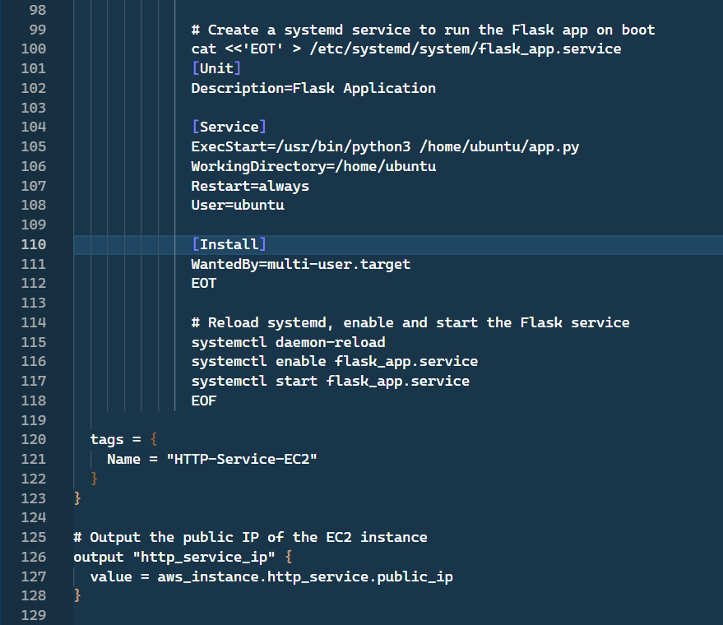

**Step 3: Deploy the Infrastructure**

1. **Initialize Terraform:**



1. **Preview the changes:**



1. **Apply the changes to create the resources:**



1. **Confirm the resources have been created. Access the HTTP service using the public IP of the EC2 instance on port 5000:**



1. **Destroy the Terraform Infrastructure:**

